EECE 200 DESIGN PROJECT
REPORT GRADE SHEET
24

TEAM NUMBER _________
Percent of Effort Distribution and Team Approval
Team Member 1
25
Elias Abou Jaoudeh
Name ______________________ Percent Effort ______% Signature
Team Member 2
Emilie Akiki
Name ______________________ Percent Effort ______% Signature
25
Team Member 3
Yara El Asmar
Name ______________________ Percent Effort ______% Signature 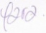
25
Team Member 4
Samer Hodroj
Name ______________________ Percent Effort ______% Signature
25
Expected Features
This grading sheet as the front page of the report. | /15
Title Page: everything centered including title, names, course, and date. | /15
Professionalism: double spacing, 11- or 12-point font, grammar, spelling, punctuation, language, consistency, writing tips followed. | /25
Table of Contents | /10
Lists of Figures and Tables | /15
Abstract or Executive Summary | /15
Introduction: Problem statement and objectives; specifications and constraints; report organization. | /15
Discussion of design process | /25
Scheduling and planning: Gantt Chart. | /20
Description of considered designs and final design (tables) | /30
Photo of design | /15
Testing and results | /25
Itemized cost summary in the form of a table or chart; comparison of anticipated cost from proposal with actual cost | /20
Individual contributions of each team member; what and how each team member contributed to this project. | /20
Conclusions and recommendations | /20
References | /15
Total Score | /300
American University of Beirut
Faculty of Engineering and Architecture
Department of Electrical and Computer Engineering
EECE 200
Introduction to Electrical and Computer Engineering
Design Project Report

Team Number 24
Elias Abou Jaoudeh
Emilie Akiki
Yara El Asmar
Samer Hodroj

January 28, 2011
Table of contents:

Page

List of Figures ii

List of Tables iii

Executive Summary iv

Introduction 1

- Problem statement 1
- Specifications and restrictions 1
- Project objectives 2
- Outline for report organization 3

Work description 4
- Discussion of design 4
- Gantt chart 5
- Discussion of alternative design 6
    - Advantages and disadvantages
    - Final design
- Testing conditions and results of final project 10
- Costs 14
- Team members’ contribution 15

Conclusions 16

References 17

Appendices 18

i
List of figures:

- Figure 0 :Speedy-33 board p.4

- Figure 1:Gantt chart p.5

- Figure 2: Design of the office p.10

- Figure 3: Front Panel of the remote site p.12

- Figure 4: Photo of the office (front view) p.13

- Figure 5: Photo of the office (from above) p.13

- Figure 6: Inside of the office p.13

- Figure 7: VI of the communication in the local site p.14

- Figure 8: The 2 groups working on the office p.14

ii
List of tables:

- Table 1: Table of costs p.14

iii

Executive summary:

In this report we are going to give a detailed overview of our project, the Green Office, discussing the software and the hardware parts. The concept of green technology was applied in a model where we controlled water flow, light, water temperature and several other functionalities in an office like displaying the door status and power rate on a seven segment display. This report will present a detailed description of the software, hardware, problems and obstacles we faced, a Gantt chart were we display the times and dates of each task, pictures of the hardware, a table displaying the cost and a logbook. We should mention that we decided to add a bit of creativity on the initial design implied by adding a camera to our office.

iv
Introduction:
Knowing the impact of pollution on our planet earth, scientists have started to search for alternatives for polluting sources, and have found a way to help our planet which is the "green technology". Green technology is proving its efficiency day after day and is becoming essential in our life since it contributes in conserving the environment. In our ECE200 project, we were asked to design a green office environmentally friendly, using LABVIEW and Speedy-33.

Specifications and restrictions:
- The project should be environmentally friendly.
- The project should be affordable.
- LABVIEW and Speedy-33 are used to manipulate and program the project.
- The Speedy-33 board will be hidden.
- The project consists of two main parts: local controller (Speedy-33) and remote controller (Laptop).
- The project will include 8 digital inputs:
- Two temperature sensors.
- A photo sensor
- Push Button for the water need detection
- A switch for changing the mode of the seven-segment display
- A push button for reading the status of the door: open or closed.
1
- A switch to select the mood of the light setting.
- A testing switch to disconnect communication between remote and local site
And one audio analog input.
- The project will include 8 digital outputs:
- An output to turn on and off the water heater (1 digital output).
- Two outputs to turn on and off two blue energy saving light emitting diodes: LED (2 digital outputs).
- Two outputs to turn on and off two yellow energy saving LEDs (2 digital outputs).
- An output to turn on and off the water pump (1 digital output).
- Two outputs to control the display on the seven segment display (2 digital outputs).
- Two outputs to transmit information to the remote site (2 analog outputs).
And one audio analog output.

Objectives:
- Use The lab session and develop the knowledge acquired in class to build a successful software
- Make use of the lectures and instructions given
- Divide the tasks equally on team members
- Cooperate as a team to build a green office
- Understand the problem solving process.
2
Outline:
In this report you will find the introduction where we state the problem, the specifications and constraints of the project, its objectives and this outline. We will be describing the work: discussing the design process, presenting a Gantt chant. We will also discuss the alternative design, designs that were considered then the design that were considered and developed and the rationale for each design and the advantages and disadvantages of each design. Also we will discuss the final design, the rationale for the final design and its advantages. We will present the testing conditions and results of the final project, the costs, and team members’ contributions in the project. In the conclusion, we will discuss design performance and features contributing to its success, summarize the previous sections and give recommendations (design improvements that could be considered in the future). Finally we will be citing the references and appendices.

3
Work Description:
Design process
Since the local site VI will be downloaded on speedy, its front panel shouldn’t be visible to the user. However, the remote site’s front panel is visible to the user. Although it doesn’t contain many controlling option the interface will be simply organized.
The blog diagram will be well organized so that the code is readable. That is so we can modify it easily in case of failure.
On the other hand, the office was designed so that it should contain all the required items and hide the wiring and SPEEDY. We were free to choose any material. Our choice was wood.

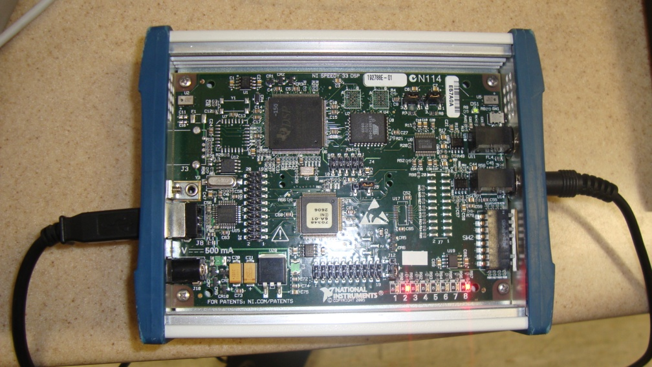Speedy-33 board
Figure 0

4
Gantt Chart:

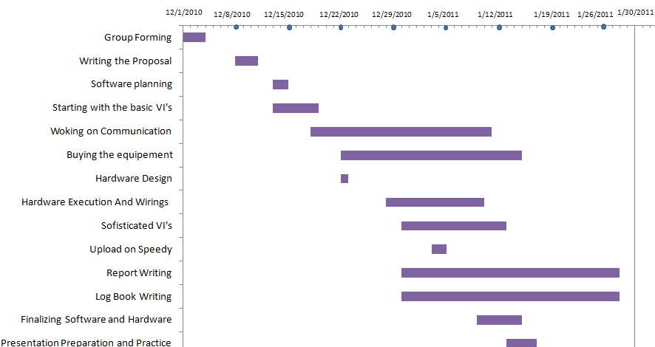

Figure 1

5
Alternatives:
- Model I:
This was going to be the regular model described in the project form. We would have:
- Two temperature sensors one with a high mark and a second with a low mark that will order to turn off and on the heater respectively depending on the temperature of the water.
- 4 LEDs (2 blue and 2 yellow) where a photo sensor will control the number of LEDs lit (1 or 2) and toggle switch will change the mood type between the blue color and the yellow color.
- 1 motion sensor that will order the pump to turn on and bring up water to the water tape.
- 1 door switch that will send to the remote site a signal concerning the status of the door.
- 1 seven segment LED that will indicate whether the number of LEDs lit or the level power consumed.
- A creative function activated from the remote site.
- 1 testing switch disconnecting the local site from the remote site.

- Advantages:
- It respects the requirements of the project
- The project will be easily built with minimum costs.
- Disadvantages:
-The project would lack of a certain unique touch.
-The project would be common to other groups.
6

- Model II
We can introduce some creative items to the basic project as:
- The remote site could have been a remote with a USB device.
- Door switch could have been replaced alarm system (Infrared joined with a sound system)
- The heater could have been a ceramic resistor or thermal solar panels.
- The external power could have been provided by photovoltaic system with solar panels.
- Another signal is sent to shut off all the lights.

Advantages:
- If built that way, the office would have been more environmentally friendly since electric power would come from a renewable energy (PV panels) which would also have been the source of the water heater.
- The actual heater would have been less prone to short-circuiting since, unlike the resistor, it wouldn’t be plunged in water.
- The ceramic resistor is less power consuming and heats water quickly.
- The alarm system which would have mode testing easy since if the alarm is set off while the remote didn’t show a result, something would have been wrong.
7
- The controller would have ensured portability of the remote site instead of it being stationary.
- We can send a signal to shut all the lights off. That will help reduce power consumption.

Inconveniences:
- Costs would have risen.
- More time would have been spent in setting them up.
- The material is not easily available.

Final Design:
- 2 Temperature sensors: one assigned a low mark and one high mark.
- The water heater is controlled by the temperature sensors. When the temperature is below the low mark, the low mark sensor will order the heater to turn on. When the temperature reaches the high mark, the heater will be stopped and deactivated till the temperature becomes less then the low mark.
- A push button that will be pressed if we wanted water. Thus, the water pump will be activated and it will pump the water. The button will return to a conditional statement after a while but the pump will remain pumping for 5 seconds because of the delay strategies put into the VI.
8
- The door switch will be pressed when the door will be closed following a simple mechanism. Therefore, a signal will be sent form the local site to the remote and a Boolean will light showing that the door is closed. In other cases, there will not be a signal sent to the remote and the Boolean will be off.
- The light sensor will detect the intensity of the light. Above a certain mark, it will order to turn on only 1 LED. Otherwise, it will order to turn on the 2 LEDS.
- The mood switch will toggle between leisure and work, IE toggling respectively between Blue and yellow light.
- The Seven segment switch will precise whether it’s representing the number of LEDs lit, or, the power level consumed. The number of LEDs can be either 1 or 2.
On the other hand, we have settled 3 levels of power: a low level of power represented by 1 on the seven segments, a medium level represented by 2 and a high level represented by 3.
In fact, each LED consumes 0.05 Watt. The water pump consumes 1.8W and the water heater consumes 30 W. Thus, if the total power consumed (which is calculated by adding the power of the elements turned on) is less than 1.5 W, so only the LEDs are lit, the level power is low. If it is less than 30W, the level power is medium. Otherwise, it will be high.
- The testing switch will disconnect the office from the remote. In other words, the connection will be impossible when the testing switch is turned on. No signal can sent or received to and from the local site.
9
- The office is built with wood with double walls to hide the wiring and a drawer where the SPEEDY-33 board is hidden and we can to easily pull out the SPEEDY-33 and work around in case of some unexpected failure

Figure 2

- A signal is sent from the remote site to activate a light sequence.
- A web camera can be posted in the office, connected directly to the remote site, displaying an updated image of the inside of the office.
- The water that is used while the pump is turned on will be goes back from the water tape to the tank again as to avoid water waste.

Advantages of Final Design:
- Low power consumption due to the light system.
- Economical use of water.
- The office is designed with wood mulch so it is environmentally friendly.
- High security level.
10
Testing Conditions:
- Software:
At first we didn't figure out so quickly how to make the temperature sensors work such that the heater turns on when below the low mark and staying on until reaching the high mark. That was fixed by having a false empty case that keeps all everything as it was so that when the temperature is higher than the low mark but lower than the high mark the heater stays it was before the temperature entered that range.
Also, at first the code was nearly unreadable due to the number of wiring going in and out of cases (and most of the time from the same source!). It made understanding our code hard, even with the documentations we had. However once we have discovered local variables, it became much easier to get things around the program.
We had some hard time separating the signals and differentiating between them to whether activate the light sequence or turning all the lights off. Thus, we had to play with the amplitude and the frequency of the signals as to reach a good result as well as we tried to overshoot “safely” with thresholds by having rough estimates with the goertzel output.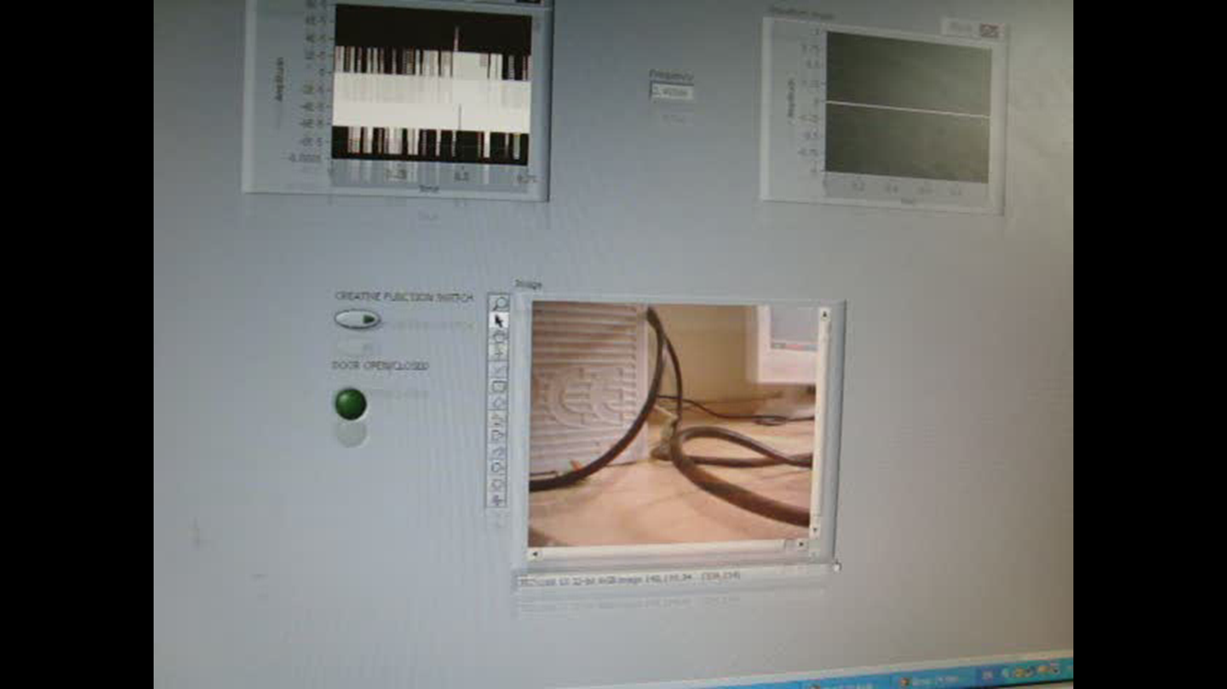
11
Figure 3
- Hardware:
After designing and planning the building of our office, we got a message stating that we could share the office with another group. Fortunately, they had put mostly a similar design so this really facilitated our work. We planned to build our office by ourselves. However, not having the right tools and skills we had to get outside help.
During our testing sessions we had constant problems with the board or computer or even the double jack. The double jack cable produced a lot of noise disturbing our software when it came to signals and thus not giving us very exact results. However simple replacement fixed it. Moreover, we weren’t able to calibrate the temperature sensors so we weren’t able if the hardware software integration concerning the heating system was properly working.
During our work, there was lack of material that was supposed to be assessed from the instructors: on the last day of testing before submitting the final VI, there was not enough of speedy board or computers for all groups. We almost missed the whole day waiting for our turn to come!
12

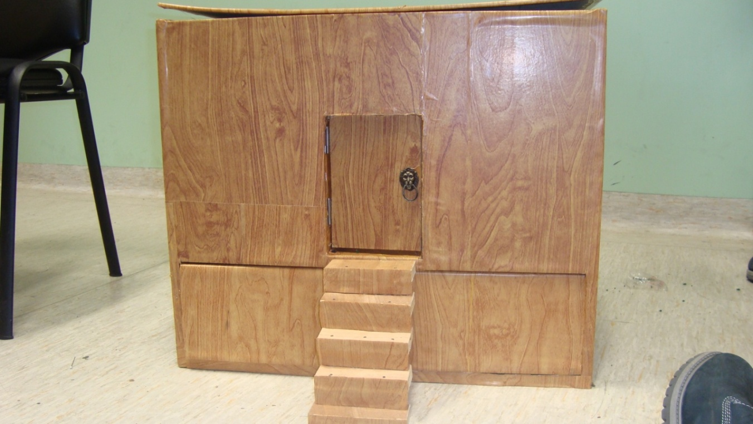
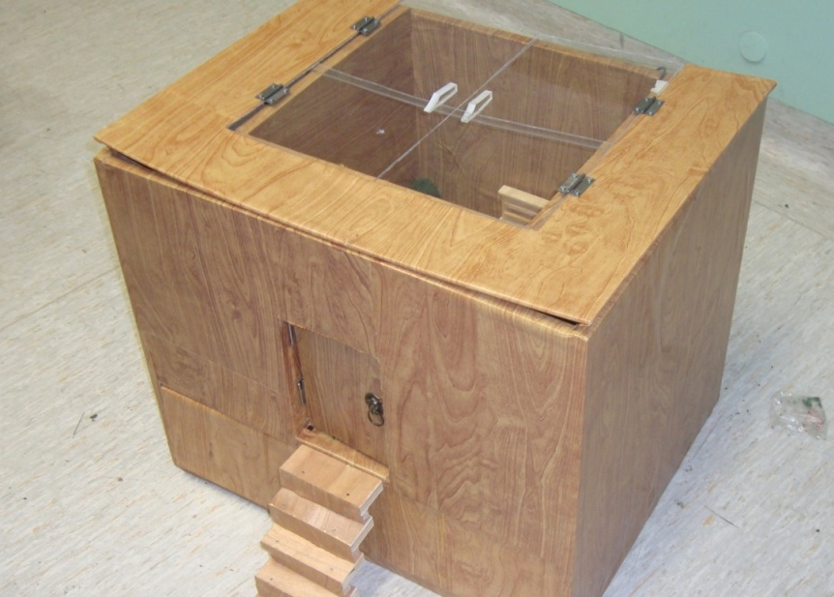
Figure 4
Figure 5
12
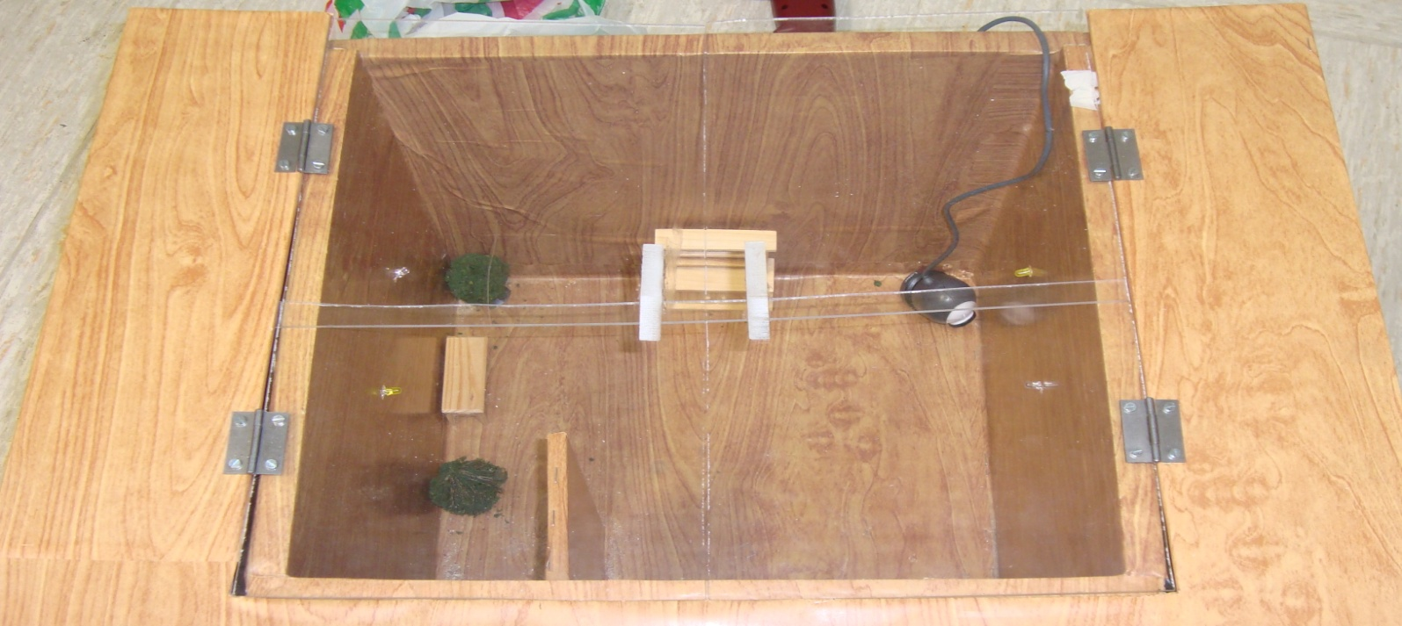
Figure 6
13

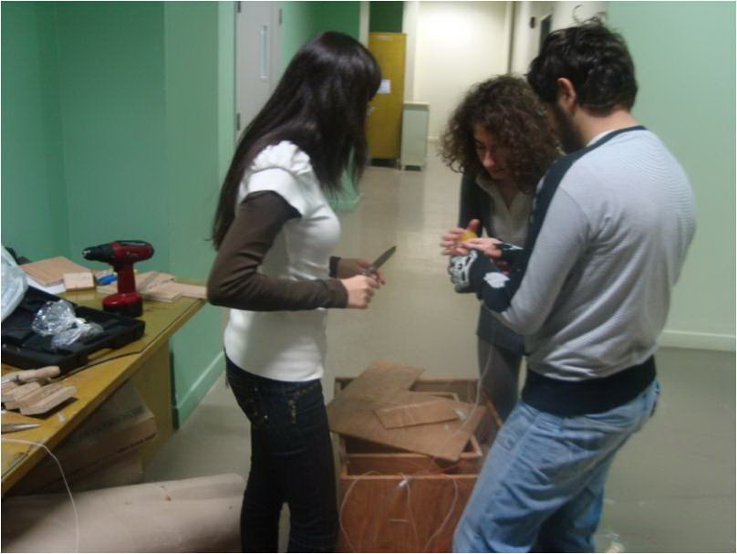
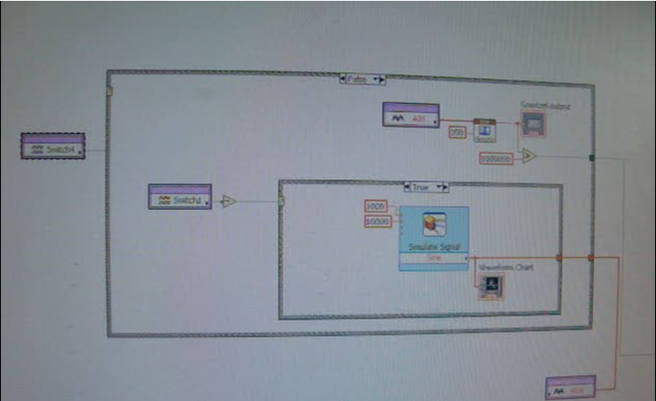
Figure 7
Figure 6

Figure 8

14
Table of Costs:
Item | Anticipated cost | Actual  cost
Laptop Computer(remote controller) | 1000$ | 1000$
Speedy – 33 + board | 600$ | 600$
Wood Box | 30$ | 60$
2 Temperature Sensors | 6$ | 1$
Light Sensor | 3$ | 1$
Motion Sensor (replaced by a push button) | 5$ | 1$
Bump Sensor (replaced by push button) | 3$ | 1$
Connection Wires | 3$ | 0$
Water Pump | 20$ | 7$
Water Heater | 15$ | 3$
LEDs + resistors | 3$ | 1$
Web Camera | 10$ | 10$
Total | 1698$ | 1685$
Table 1

15
Team member’s contribution:

Since we are at our first stage of our knowledge in engineering, the final project was the result of all the group members working together in the different fields that demand the project going from the software, hardware writing work to the connections. However, for more organizations every member contributed somehow more in a specific field.
Elias Abou Jaoudeh,
Elias helped in the project by applying his passion for math and physics in finding equations for thermal energy and will contribute in the design of the software.
Emilie Akiki,
Emilie concentrated her part in the project on reviewing and editing all the written work; reports, log book, drafts…
Yara El Asmar,
Yara worked on designing the office and organizing all the wirings and getting the required equipment and hardware necessary to the project.
Samer Hodroj,
Samer was responsible of working on the wiring and the translation phase from software part only, and the part of software and hardware work simultaneously.

16
Conclusion:
The project is the result of the cooperation between 4 members. We have learned that, as future engineers, we have responsibilities towards our project, team members and consumers. This project was successful, mostly thanks to the simplicity of hardware-software integration between Lab-VIEW and the SPEEDY-33.

As we have seen, this office model contains all the basic elements of a modern house (electricity, water and heating). It functions in an environmentally friendly manner by not consuming more power than it needs. We had discussed alternative designs during our work, however they were discarded due to their impracticality and high cost. We faced a few problems when implementing our initial design since some models of the software didn't translate too well into the hardware, so we fixed them.

Despite the simplicity of the hardware-software integration, the SPEEDY-33 had a lot of problems with the communication model. Different SPEEDY's would give out different signals making our communication system a pretty tedious part to adhere into the office. We would have liked that the information we sent and received from remote site and SPEEDY to be consistent, even if it wasn't in a perfect (that isn't possible anyhow). But it is one thing when sending a signal and another who proved to be effective the first time, to be ineffective another and having responded in the same manner to them. Our main problems came from different hardware. Some are pretty predictable and we have taken them into account by having different designs. However, many were wild and to us unfixable.
17
References
http://www.ehow.com/how_4811706_gantt-chart-excel.html

http://ieeexplore.ieee.org/xpl/freeabs_all.jsp?arnumber=5281185

www.ehow.com/how_16566_write-executive-summary.html

www.hodu.com/exec-summary.shtml

18
Appendices:
A) Tools used in Software
- Goertzel Algorithm
The Goertzel algorithm is used in digital signal processing to recognize components of a frequency of a signal. Here it is used to identify the energy of the signal.

- Local Variables
Local variables are variables used exclusively in one function of a program, in contrast with global variable which can be used in any function. However considering our code as a whole is one big function, they come off being the same here.

- Logic Operators
Throughout our code we have to compare true or false values. For this we used logic operators such as ¬, v and ^.
¬ is the NOT operator, it reverses the value of the input, giving false when it's true and true when it's false.
ѵ is the OR operator, it tests the inputs such that the input is true if and only either of the inputs or both are true. Otherwise, it's false.
19
^ is the AND operator, it tests the inputs such that the output is true if and only if both are true. Otherwise, it's false.

B) Environmentally Friendly
The green office was built in support of an environmentally friendly lifestyle. Its main method of being environmentally friendly is by having as low power consumption as possible.
Energy is provided mainly from fossil fuels. That usage has as an effect the release of Carbon dioxide, among gases. It is the main cause of global warming by green house effect. 36 tones of CO2 released every year!
Global warming ruins the balance of the ecosystem for example making some habitats unlivable for animals that used to live there.
It is our duty then as the dominating species on earth to protect our environment.
The green office helps then by releasing fewer gases with green house effects into the atmosphere.

20
C) LOG BOOK

MONDAY DECEMBER 6: “First Meeting”
Time: 11:00-14:00
Place: Charles Hostler Cafeteria
Objectives: Analyzing the Project
After the group forming, we met on this day to discuss and understand the whole project, we explained to each other and we did a brainstorming. We checked the deadlines, talked a bit about the proposal and assigned a next meeting.
Things to do for the next time: Proposal

WEDNESDAY DECEMBER 8: “Proposal Meeting”
Time: 11:00-14:00
Place: Jafet Library Study Room 4
Objectives: Writing the proposal
We began by dividing the work. Each member of the group was responsible of writing a part of the proposal. Every person worked o his part and we helped each others. Writing the proposal was not very difficult we followed the instructions and the grading sheet. We couldn’t finish everything every member continued his work alone and we gathered them later on.
21
Things to do for the next time: Beginning to work on the software.

MONDAY DECEMBER 13: “1st Software meeting”
Time: 12:00-14:00
Place: SRB Room 307
Objectives: Working on the software.
We began to work on the software and we were a bit confused and unable to work very efficiently we could only figure out how to do the LED’s part.
Things to do for the next time: Continue the work on the Software.

TUESDAY DECEMBER 14: “2nd Software meeting: Bad Day”
Time: 10:00-11:00
Place: SRB lab 4
Objectives: Working on the software
We tried to work on the software but since it was the registration day we could not focus on the project. This meeting was useless.
22
Things to do for the next time: Continue the software.

SATURDAY DECEMBER 18: “3rd Software meeting”
Time: 10:00-18:00
Place: SRB Room 307
Objectives: Working on the Software
We worked on the software, we faced some difficulties and we took some time to start working efficiently because we had a quiz on this day. We almost finished all the software except the communication part. We came across a little confusion concerning the seven segment display, but we overcame the difficulties with patience and more concentration.
Things to do for the next time: Finish the software before the deadline!

SUNDAY DECEMBER 19: “4th Software meeting”
Time: 14:00-20:00
Place: SRB Room 307
Objectives: Finishing the Soft Demonstration before the deadline!
23
We met on Sunday because we had to finish Software before Monday. We worked on the communication and on the power, but unfortunately we lost our work without saving it! Ouch! We had to repeat everything again! And we did.
Things to do for the next time: Designing the Hardware.

WEDNESDAY DECEMBER 22: “Hardware design and decision making”
Time: 11:00-13:00
Place: Study Room 2 Jafet Library
Objectives: Designing the hardware and schedule meetings in the break + buying the supplies
We met on this day to draw a design for the hardware and we written down all the measurements and decided to make the office with wood mulch. Then we decided when to meet during the Christmas break and who is going to buy the required supplies.
Things to do for the next time: Hardware execution.

WEDNESDAY DECEMBER 29: “Meeting with the other group”
Time: 9:00-12:00
Place: SRB F1
24
Objectives: Meeting with the other group and starting to work on the hardware
After we got Miss Sarah Khaddaj email that two groups had to share the same hardware we fixed a date to meet with the other group. Samer had already bought the wood plates. We met in SRB F1 in front of the workshop since we thought that it might be open. We tried to build the hardware but we didn’t move forward that’s why we decided to get a help of a carpenter so that our office will be well built. That day wasn’t very fruitful but we got to meet the group we were going to share the hardware with.
Things to do for the next time: Take the wood to a carpenter + working on the wirings and on the software.

THURSDAY DECEMBER 30: “2nd meeting with the other group: Working on everything”
Time: 9:00-6:00
Place: SRB
Objectives: Working on the Hardware
We worked on everything on this day indeed. Two members left to the carpenter’s. We worked a bit on the software, on the communication part and on the door part. We did mostly all the wirings, and we started to brainstorm our report. It was a very long work day we borrowed Speedy and worked on it too.
Things to do for the next time: get the office from the carpenter and put all the required stuff in the office.
25

After the Christmas vacation we had almost 2 weeks to finalize the entire project, that’s why we used to meet in every spare time we had during the day but our most important meetings were:
MONDAY JANUARY 5: “Hardware”
Time: 11:00-13:00
Place: SRB F1
Objectives: Working on the Hardware
We covered the office by wallpaper that had the color of wood.
Things to do for the next time: Place the required inputs and outputs in the office/

FRIDAY JANUARY 7:”Hardware”
Time: 19:00-23:00
Place: SRB F1
Objectives: Placing the inputs and outputs
After a long day some of us stayed at AUB to bore holes in the office in order to enter the wires and the required inputs and outputs. Almost all the required things were placed.
Things to do for the next time: Finalizing the Hardware+ Software+ Labeling the wires
26

MONDAY JANUARY 10: “Hardware”
Time: 11:00-13:00
Place: SRB F1
Objectives: Cleaning the Hardware and arranging the wallpaper
We fixed all the wallpaper and we tested the LEDs but unfortunately we damaged all the LEDs so we had to buy new ones. We still didn’t find an IR transceiver
Things to do for the next time: Labeling the wires+ software
TUESDAY JANUARY 11: “Software day”
Time: 10:30-14:00
Place: SRB 307/F1
Objectives: Working on communication and all the VIs + extra work ( camera) + labeling
After working on the communication it finally worked! And the software part was supposedly done with a special touch from the group which consisted of placing a camera in the office. We labeled all the wirings too on that day. But unfortunately in the end of the day the communication didn’t work.
Things to do for the next time: Buy new LEDs search for an IR transceiver
27
WEDNESDAY JANUARY 12: “BOARD”
Time: 11:00-3:00
Place: SRB
Objectives: wires connection to the interface board
We replaced the LED’s by new one. M. Joujou connected the wires to the interface board and told us to replace the IR transceiver by a push button.
Things to do for the next time: Start working on the Power point presentation and the report.

THURSDAY JANUARY 13: “PRESENTATION+REPORT”
Time: 8:00-2:00
Place: Study room 2 Jafet Library
Objectives: Working on the Report and the Power Point presentation
We divided the work on the report and everyone started to work on his part, then we did an outline for our presentation and everyone prepared his oral part and what he had to say in a way that each one of us had 2min and a half to talk since the total time of the presentation was 10mins
Things to do for the next time: Everything left.
28
FRIDAY JANUARY 14: “ALL IN ALL”
Time: 12:00-7:00
Place: SRB 311
Objectives: try to finish everything
We tried to work on everything on that day, the communication was sometimes working and sometimes not we tested the software on the hardware the photo sensor wasn’t working all the time. We worked on the presentation too. We finalized what we had to say.
Things to do for the next time: Final touches.

SATURDAY JANUARY 15: “Last day of work!”
Time: 9:00-4:00
Place: SRB 311
Objectives: MUST finish everything
The hardware was ready the software not really we couldn’t test it anymore because there were not enough speedy 33 boards nor computers all the groups were in the labs to work. We tried to finish the power point presentation but we couldn’t.
Things to do for the next time: Practice the presentation
29
MONDAY JANUARY 17: “Presentation Practice”
Time: 11:00-1:00
Place: Jafet Library 2nd floor
Objectives: Make sure that our presentation satisfies the grading criteria
Everything was submitted to moodle the day before we were only left to our presentation practice we fixed some things in what we had prepared to say and we timed our presentation.
Things to do for the next time: Presentation

TUESDAY JANUARY 18: “DONE!! ”
Time: 11:00-12:00
Place: SRB 307
Objectives: Presentation!!
Before going to the presentation we practiced what we wanted to say, then we left to SRB 307, things didn’t go as we wanted 100% but it’s ok we had learned from this project many things that it doesn’t matter if everything worked 100% or not.
Things to do for the next time: Report
As for the report writing everyone worked a bit on it in his home and here we are finishing the last sentence.
30

